EQUIPMENT NEEDS ASSESSMENT APPLICATION

Name of Person Submitting Request: | Denise Knight
Program or Service Area: | Child Development
Division: | SSHDPE
When was the last Program Efficacy document completed? | Spring 2008
What rating was given? | Continuation

- What equipment are you requesting?
The Child Development department has an academic as well as vocational orientation. The academic program prepares students for Associate of Arts degrees that articulate with educational institutions that offer BS/BA degrees in Child Development. The vocational program which interfaces with the academic program allows students to develop skills suitable for immediate employment. The certificate programs provide a well-rounded, concentrated area of study in child development. At the present time, the department has eight certificates and three AA degrees. The department functions to provide the academic foundation necessary for students to become successful providers of early childhood care and education.

In the summer of 2010 the Child Development Department was relocated from North Hall to the North Hall Replacement. The greatest loss in this move has been adequate storage. In the old North Hall building the Child Development Department had a combined storage capacity in excess of 750 square feet. This capacity included a resource room, two storage closets with built-in shelving, Rubbermaid storage cabinets, closets, cupboards, drawers etc. The new North Hall has room for storage in the classroom (approximately equivalent to what was available in the old North Hall classrooms) as well as two empty rooms NHR 219 and 220 designated for additional storage. Unfortunately these two rooms together only total approximately 250 square feet. There is mounted shelving and five Rubbermaid units we brought from the old North Hall in NHR 219 and two additional Rubbermaid units in NHR 220. Although we have taken seven Rubbermaid units from the old North Hall we were only able to reduce the number of boxes from over 250 to just under 90. There is no built-in shelving to accommodate the curriculum materials currently being stored in the remaining 90 boxes. We would like to request two 72hx24dx72w shelving units at $138.97 (one for each room) and four 36h x16.58d x33w storage units on wheels at 79.97 (two for each room) for an approximate total of $650.13.

- Indicate how the content of the EMP One-Sheet and latest Program Efficacy Report support this request. How is the request tied to program planning? (please reference the page number(s) where the information can be found on the EMP and Program Efficacy).

The current analysis of the EMP data (pg 31) indicates that the FTES have steadily been increasing since our section reduction in 2006-2007. Our retention rates are consistent with the college/division and the number of certificates and degrees awarded are on the increase. SLOS have been completed for every course and all assessments are up-to date. We anticipate continued growth in the future.

- Indicate if there is additional information you wish the committee to consider (regulatory information, compliance etc).

An integral part of the certificates and degrees the Child Development Department offers are curriculum classes. These courses allow faculty to demonstrate developmentally appropriate practices to our Child Development students. These “best practices” show our students how to enhance the learning process through hands on experiences. We currently teach six sections of CD 114, four sections of CD 205 and one section of CD 074,130, 133, 134, 136, 138, 161,168,186 and 210, 215 annually. It is these classes that utilize the hands on materials currently awaiting shelving. In the past students had ready access to the curriculum materials housed in our storage areas. The items were labeled and in many cases color coded for easy access. Most instructors require students to plan a minimum of five developmentally appropriate activities around a central theme provided in the lecture and then present this activity to his/her fellow students. It is during these presentations that the curriculum materials are used.

- Evaluation of related costs (including any ongoing maintenance or updates) and identification of any alternative or ongoing funding sources. (for example Department Budget, VTEA or Perkins)

Our request is for two 72hx24dx72w shelving units at $138.97 each (one for each room) and four 36h x16.58d x33w storage units on wheels at 79.97 each (two for each room) for an approximate total of $650.13. There are no additional funding sources and no ongoing maintenance required.

- What are the consequences of not funding this equipment?
There are two challenges: students need access to a variety of supplies and materials necessary to complete the required assignments. These materials can be made available to them if they could be displayed on shelves as opposed to storage boxes. Without access students would have to purchase curriculum supplies out of their own pocket. The additional costs associated with taking our curriculum classes would pose an unnecessary hardship for many of our students. Additionally those instructors that utilize hands on materials to reinforce their lectures are now placed at a disadvantage. Each time an instructor wants to do a group project they have to spend an inordinate amount of time going through boxes to find the necessary materials. Once materials are located and used for demonstration they have to be placed back into bankers boxes instead of being unpacked because there’s no place to put them.

Existing Storage space NH 219

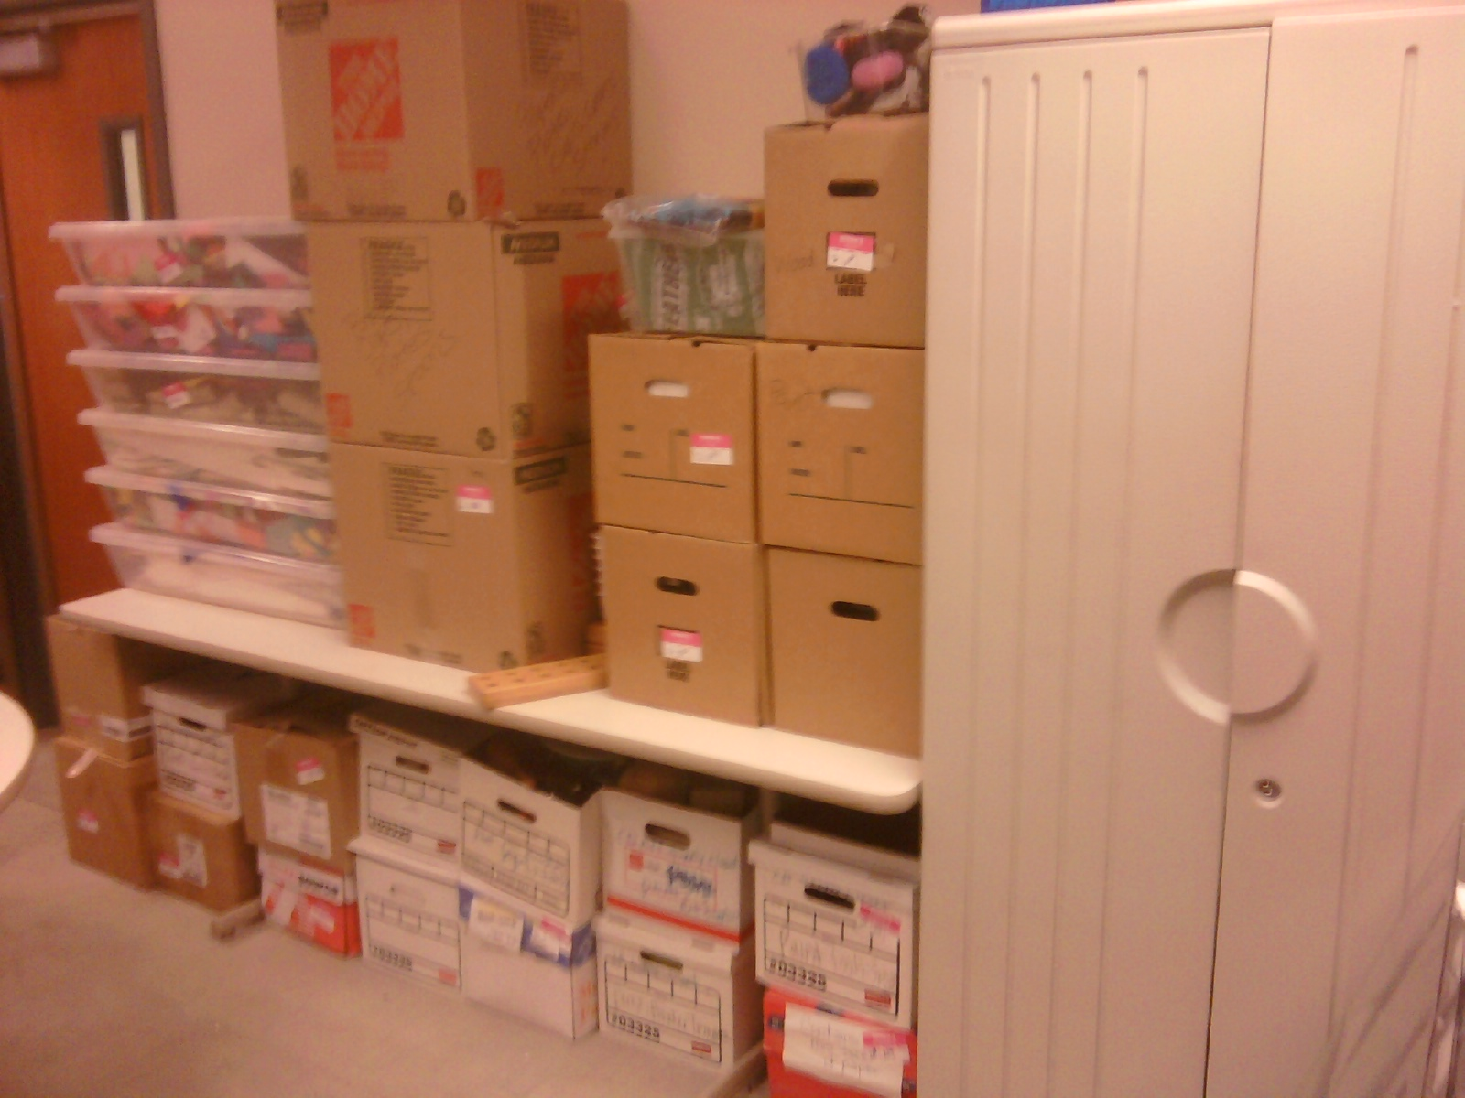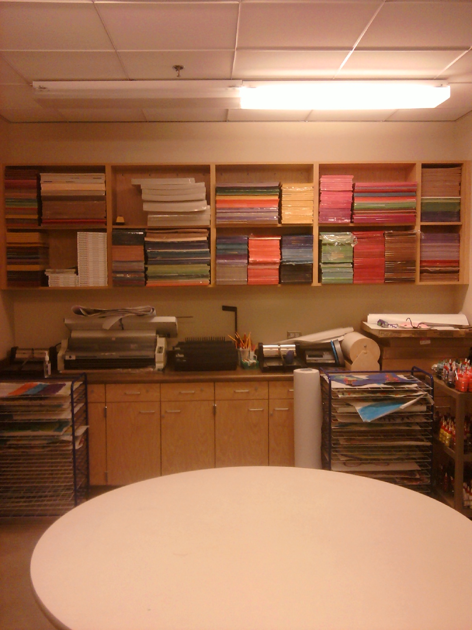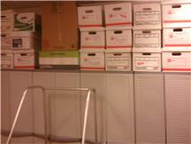

Existing Storage space NH 220
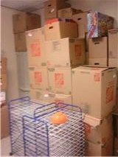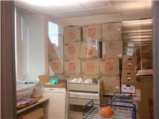

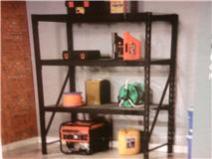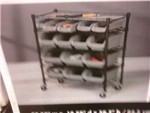
(2) 72hx24dx72w (4) 36h x16.58d x33w
Shelving unit (this unit slides under the last row of shelving)

